Appendix A - STAR survey action plan 2022

Action | Action owner | Milestones | Key Dates/Timescales
1.0 - Repairs service
1.1 – Bring in SMS messages for repairs to cover the confirmation of appointments, day before reminders, operative on the way notifications and post-work satisfaction surveys. | Paul Concannon, ODS Director of Property Services | SMS messaging system for appointments in place. | 31/07/2022 (provisional)
1.2 – Creation of live dashboards so ODS can deal immediately with less than satisfactory customer responses. | Paul Concannon, ODS Director of Property Services | Dashboards scoped and designed.  Dashboard constructed in Power Bi following rollout of SMS messaging system for appointments. | Completed  30/11/2022 (provisional)
1.3 - Full rollout of DRS (dynamic resource scheduling) for operatives to improve responsiveness to customers. | Paul Concannon, ODS Director of Property Services | DRS (dynamic resource scheduling) deployed for 50% of operatives in ODS.  DRS (dynamic resource scheduling) deployed for 100% of operatives in ODS. | Completed  31/07/2022 (provisional)
1.4 - Grafton stock contract with on demand stock deliveries for fixed right first time repairs. | Paul Concannon, ODS Director of Property Services | Van stocks deployed and just in time delivery service up and running. | Completed
1.5 - Use of QL First Touch solution to enable operatives to book follow up calls with customers whilst on site. | Paul Concannon, ODS Director of Property Services | QL First Touch solution deployed for 50% of operatives in ODS.  QL First Touch solution deployed for 100% of operatives in ODS. | Completed  31/07/2022 (provisional)
1.6 - Implement the QL Portal to enable tenants to report, view and track repairs. | Bill Graves, Landlord Services Manager | Deployment of customer portal (Rents, Repairs, Choice Based Lettings) | 31/10/2022 (provisional)
1.7 – Carry out a proactive programme to revisit cases where damp and mould have been reported in the past to review whether measures taken have worked or not. | Paul Concannon, ODS Director of Property Services | All mould and damp works prioritised when identified.  All cases in last 2 years contacted to see if there are any ongoing issues.  A mould and condensation prevention video launched and linked to OCC website. | Ongoing  Completed  Completed
1.8 - Customer care training for all staff in ODS centred on communication, behaviours and delivering a right first time service. | Paul Concannon, ODS Director of Property Services | EDI training for all staff  Customer care training developed.  Training rolled out to all ODS staff. | Completed  Ongoing (linked to timescales on text survey and dashboards)
1.9 - Develop a new ODS Customer Service Strategy, encompassing customer experience, journey mapping, sentiment and real time transactional performance management. | Paul Concannon, ODS Director of Property Services | Project Manager appointed.  Customer Service Strategy in place. | 01/04/2022  31/03/2023
2.0 - Quality of the home and the neighbourhood – planned maintenance
2.1 - Deliver £51m HRA investment programme to accelerate the replacement of key asset management items (pending approval of council budget). | Mark Smart, HRA Surveying Manager | See capital spend budget below action plan for details  Investment programmes delivered including:  • doors and windows  • re-roofing  • structural repairs  • lifts and door phone entry systems  • cyclical repairs and decoration  • internal communal area improvements | 2026 (in line with yearly budget profile)
2.2 - Carry out a full stock condition survey of council homes to assess what work is needed over and above Decent Homes in future (pending approval of budget). | Mark Smart, HRA Surveying Manager | Data set for collection selected and tender prepared and tenders invited.  Survey contractor appointed.  Stock survey completed.  Develop a 5 year rolling programme informed by the results of the stock condition survey as they become available. | March 2022  30/04/2022  31/03/2024
2.3 - Continue to invest through the Great Estates programme for flat block improvements and parking, including £1.1m in 22-23. (The Great Estates budget is dedicated to low rise building communal spaces, improvements in security/lighting/entrance doors and access to a useable green space.)  Barns Road Before  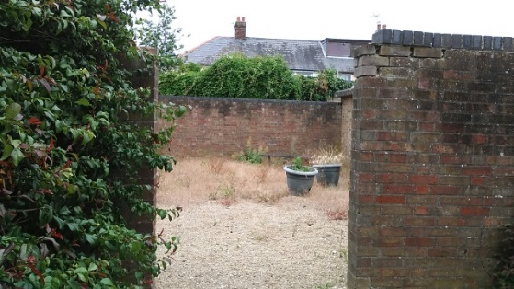  Barns Road After  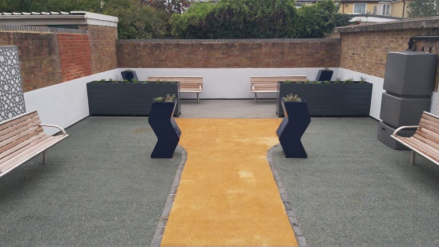 | Sue Briscoe, Great Estates Senior Surveyor | 2021/22 programme completed.  Sites for 2022/23 programme selected and programme commenced.  See below for budget numbers | 31/01/2022  01/03/2022
3.0 Communications and engagement
3.1 – Increase the resourcing of tenant engagement activity (subject to budget approval), in order to develop and rollout a tenant engagement campaign, which will include areas such as –  - building safety  - personal fire safety  - carbon reduction programme (further detail 3.4)  - digital channel shift | Bill Graves, Landlord Services Manager | Recruitment of new Customer Experience team to develop and deliver engagement plan | 30/06/2022  31/03/2024
3.2 – Take further steps to better understand our tenants, with more accurate capture of tenants’ personal data, contact details, data preferences and protected characteristic information. | Bill Graves, Landlord Services Manager | QL First Touch forms implemented.  QL customer portal launched | 30/06/2022  31/03/2024
3.3 – Further improve our digital offer to deliver improved communications and engagements to tenants who prefer digital means of communications, such as younger people. | Bill Graves, Landlord Services Manager | Development and rollout of engagement plan  QL customer portal launched | 30/06/2022  31/03/2024
3.4 - Launch a specific communications and engagement campaign to support the decarbonisation and retrofitting of council homes with energy efficient improvements. | Bill Graves, Landlord Services Manager | - Phase one:  - Use advertising and editorial to encourage tenants to look out for a letter from the council.  - Initiate a programme to collect fully permissioned email addresses for all council tenants.  - Phase two:  - Send a letter to all homes affected  - Tenant Involvement wider activity  - Phase three:  - Send a letter to all homes that have not yet signed up, with instructions on how they can arrange a 1-2-1 with a Tenant Advocate/Champion.  - Decarb training to the registered Tenant Advocates/Champions.  - Digital media  - 1-2-1 sessions with undecided tenants via a zoom calls, or non-digital alternatives.  - Phase four:  - Build the wider engagement team. Identify programme – advice, signposting, dropping leaflet etc. | 30/06/2022  31/03/2024
4.0 - Antisocial behaviour
4.1 – Community Safety and Tenant Involvement to work together to carry out engagement work with tenants about ASB to better understand the feedback from the Tenant Survey and identify any improvements. | Liz Jones, ASBIT Manager | Complete a programme of engagement with tenants on the subject of ASB  Agree any changes in the Community Safety team from the learning and feedback | 31/07/2022  30/09/2022
4.2 – Improve the Council’s online ASB offering, with more information on support available and on what services the Council can provide. | Liz Jones, ASBIT Manager | Go live of new web pages | 31/07/2022
4.3 - Implement the updated antisocial behaviour policy (November 2021) which focuses on the support and protection of victims of antisocial behaviour and has a positive impact on people with protected characteristics. For those suspected of causing antisocial behaviour, mental health is often a feature and the revised policy requires that officers identify where possible support needs of perpetrators and seek to address them in partnership with third sector and statutory partners. | Liz Jones, ASBIT Manager | Implement the policy in full | Ongoing
5.0 Housing Services
5.1 - Deliver the service integration project, linking Housing, Communities and Community Safety functions, aiming to further improve how we bring our teams, our customers and our partners together to deliver joined up services to residents of Oxford, including our tenants. This includes the objective to create locality teams made up of people from relevant services, who will work closely with our communities and partners to deliver cross-team solutions for customers in need. | Stephen Clarke, Head of Housing Services | Complete and report on the locality based pilots  Deliver the overall SIP project | 31/03/2022  31/03/2023
5.2 - Recruit additional resources for frontline housing management services, including Tenancy Management and Allocations to improve case work (subject to budget approval) | Bill Graves, Landlord Services Manager | Recruitment of new posts | 30/04/2022  30/06/2022
5.3 - Commission an external review of how the council delivers its services to tenants as a landlord to inform our thinking. | Stephen Clarke, Head of Housing Services | Instruct an external consultant  Receive report | 28/02/2022  30/05/2022
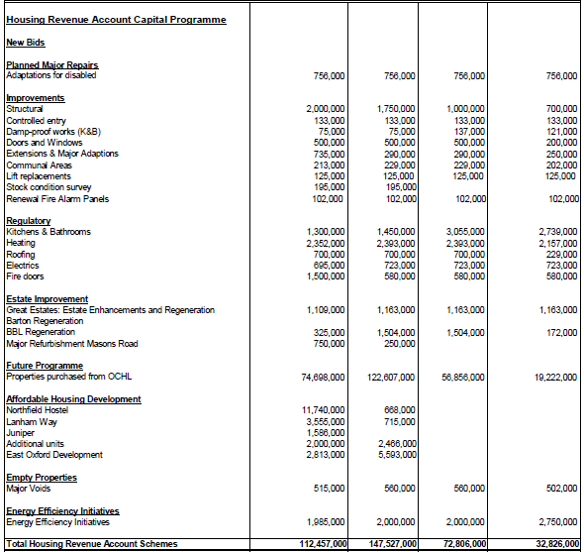

 | 2022-23 | 2023-24 | 2024-25 | 2025-26 | Total
Planned Major Repairs
Adaptations for disabled | 756,000 | 756,000 | 756,000 | 756,000 | 3,024,000
Improvements
Structural | 2,000,000 | 1,750,000 | 1,000,000 | 700,000
Controlled entry | 133,000 | 133,000 | 133,000 | 133,000
Damp-proof works (K&B) | 75,000 | 75,000 | 137,000 | 121,000
Doors and Windows | 500,000 | 500,000 | 500,000 | 200,000
Extensions & Major Adaptions | 735,000 | 290,000 | 290,000 | 250,000
Communal Areas | 213,000 | 229,000 | 229,000 | 202,000
Lift replacements | 125,000 | 125,000 | 125,000 | 125,000
Stock condition survey | 195,000 | 195,000
Renewal Fire Alarm Panels | 102,000 | 102,000 | 102,000 | 102,000
 | 4,078,000 | 3,399,000 | 2,516,000 | 1,833,000 | 11,826,000
Regulatory
Kitchens & Bathrooms | 1,300,000 | 1,450,000 | 3,055,000 | 2,739,000
Heating | 2,352,000 | 2,393,000 | 2,393,000 | 2,157,000
Roofing | 700,000 | 700,000 | 700,000 | 229,000
Electrics | 695,000 | 723,000 | 723,000 | 723,000
Fire doors | 1,500,000 | 580,000 | 580,000 | 580,000
 | 6,547,000 | 5,846,000 | 7,451,000 | 6,428,000 | 26,272,000
Empty Properties
Major Voids | 515,000 | 560,000 | 560,000 | 502,000 | 2,137,000
Energy Efficiency Initiatives
Energy Efficiency Initiatives | 1,985,000 | 2,000,000 | 2,000,000 | 2,750,000 | 8,735,000
TOTAL |  |  |  |  | 51,994,000

Estate Improvement | 2022-23 | 2023-24 | 2024-25 | 2025-26 | Total
Great Estates: Estate Enhancements and Regeneration | 1,109,000 | 1,163,000 | 1,163,000 | 1,163,000 | 4,598,000
Barton Regeneration |  |  |  |  | 0
BBL Regeneration | 325,000 | 1,504,000 | 1,504,000 | 172,000 | 3,505,000
Major Refurbishment Masons Road | 750,000 | 250,000 |  |  | 1,000,000
 | 2,184,000 | 2,917,000 | 2,667,000 | 1,335,000 | 9,103,000

